**OPERATING SYSTEMS**

**Laboratory 6**

Name:

Surname:

Index number:

Date: 20.04.2021

**Introduction**

* 10 points maximum.
* All commands must be executed in the Linux terminal. Don't use Linux GUI to solve the exercises.

**Exercise 1. (5 points)**

Write a script that will calculate the number of lines in the /etc/passwd file and display it to the screen.

*Paste the script: first I made a file with text*

*After that I wrote for count line code is down below*

*Wc -l line (line is my text file)*

*Paste the screenshots of the completed script:*

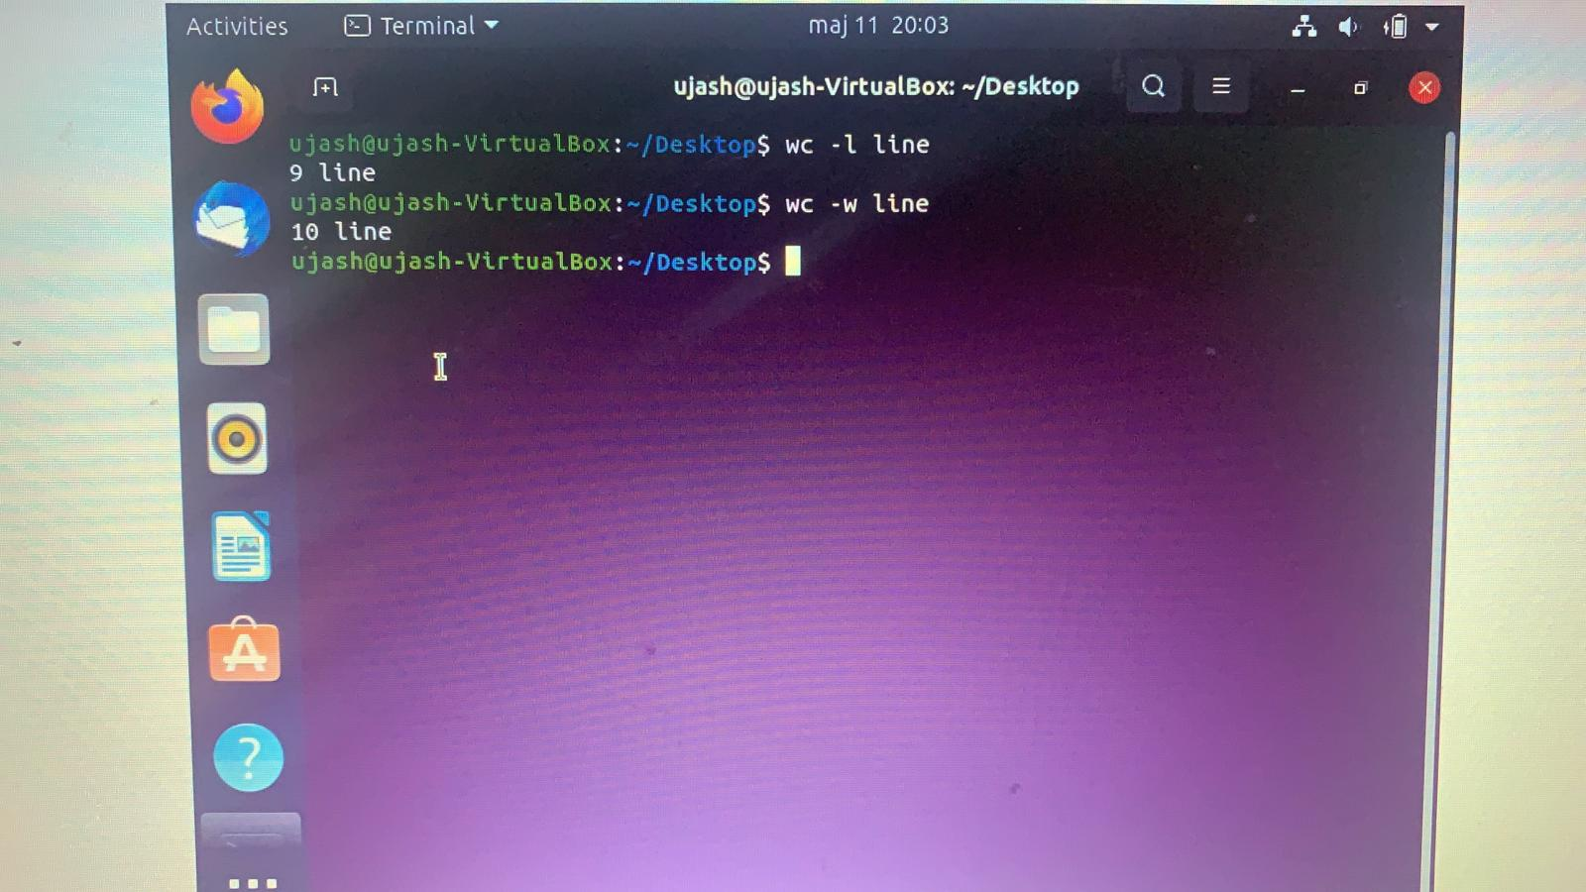

**Exercise 2. (5 points)**

Write a script that will assign the value of the $HOME system variable to var1 variable. Then write the value of the variable var1 to the screen.

*Paste the script:*

*Vi ~/*

*Export PATH = $PATH:/OPT/apss:$VAR1/bin*

*Paste the screenshots of the completed script:*